(1) Ensure py_dajngo_pg_winn is up to date

(2) log into WINN host machine

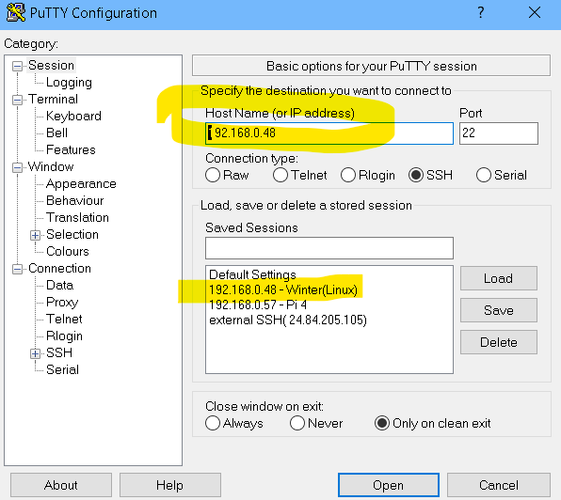

(3) cd /var/www/ww-site

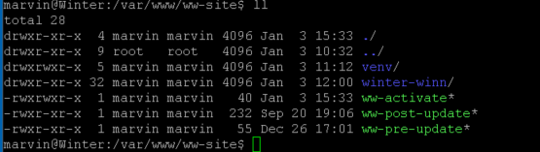

(4) sudo ./ww-pre-update (OR sudo chown marvin:marvin winter-winn -R )

(5) cd winter-winn

(6) Fetch the repo from remote:

git fetch –all   
git reset –hard origin/master

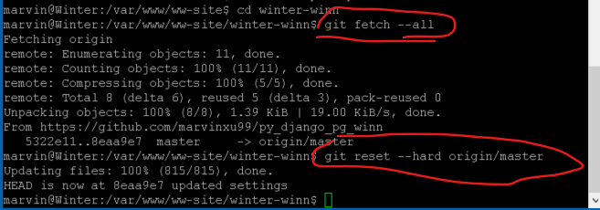

User git remote -v to ensure the correct repo:



(7) source ../venv/bin/activate to activate the VENV

(8) Migrate data as needed

python3 manage.py makemigrations,

python3 manage.py migrate

(9) python3 manage.py collectstatic

(10) Make compile messages as needed;

Python3 manage.py compilemessages -l zh_Hans

(10) cd .. to /var/www/ww-site

(11) sudo ./winter-winn-post-refresh

(12) sudo systemctl reload apache2